|  |
| --- |
| **NUCL 355 Experiment 6** |
| Friction in Pipe and Similarity Law  Professor M. Bertandano |
|  |
| School of Nuclear Engineering  Purdue University  Report of the Experiment By:  Weston Cundiff, Stephen Cox, Kara Luitjohan, Patrick Burk, Dominic Ghering, Michael Stryker, Austin Curtis, Matt Metzger, et. Al. |
| **Written By Alex Hagen** |
| **3/1/2011** |
|  |

# Executive Summary

Flow elements cause certain amounts of loss in realistic systems. Throughout this course, we have previously used models which did not take loss through minor or major effects into account, providing an overestimate for velocities and dynamic heads. In this experiment, these losses were characterized to provide realistic models of loss within flow systems.

An experiment was done to characterize the losses through certain pipe elements, as well as throughout an entire system of piping. The experimental setup is created by connecting in order the piping elements to be studied into a typical horizontal flow system. A pump was used to circulate water at high rates, with a magnetic flow meter giving the correct volumetric flow rate. This could be used as a way to characterize the flow through these elements at different speeds. The pipe elements included were an orifice plate, a sharp corner, a smooth corner, an expansion, and a contraction. It is also notable that loss can be calculated throughout the entire system from friction losses.

Data was acquired using two Honeywell pressure transducers connected to digital multimeters. These pressure transducers could be selectively attached across each different flow element, as all flow elements included flange taps across them. This data was taken for five different flow rates, with different values being measured at each flow element. This data then could be calibrated to give the pressure drop across each respective flow element.

The data acquired was analyzed exhaustively for each flow element. The pressure drops across each flow element were calculated, and from there they could be plotted against Reynold’s Number, to characterize the changes with flow parameters such as velocity. Because of analytical solutions to friction factor and minor loss in expansion or contraction, these could be compared to the measured values. Through the corners, analytical solutions for expected pressure drops were not available, so the coefficient of loss was calculated and compared to accepted values.

Conclusively, analytical solutions for these losses are inaccurate and unreliable. Certain trends were calculated when exactly the opposite were measured. The losses for major losses and the bends gave decent estimations, but some of the minor losses were off by orders of magnitude. It is a conclusion of this experiment that analytical solutions for loss in flow systems should always be benchmarked against experimental results.

# Introduction and Theory

The experiment that follows describes dynamic flow in a more realistic way than has previously been experimented through in this course. Through this experiment, losses and other non-conservative pressure losses were solved for, which is a much more realistic approach. In previous experiments, only the ideal pressure distribution was taken into account, using only the typical Bernoulli Equation:

$$P+\frac{ρV^{2}}{2}+zg=P_{2}+\frac{ρV_{2}^{2}}{2}+z_{2}g$$

For this experiment, there are several types of losses that must be considered. These losses can be categorized as major and minor losses, with major losses occurring because of friction within the pipe, and with minor losses occurring through pipe elements such as bends and elbows. These additions make the Extended Bernoulli Equation turn into:

$$P+\frac{ρV^{2}}{2}+zg=P_{2}+\frac{ρV_{2}^{2}}{2}+z_{2}g-P_{loss, Major}-P_{loss, Minor}$$

The first type of loss, major loss, occurs because of the inherent roughness of surfaces in pipes. The friction factor defines this type of loss, but it is not a constant loss. Because of the formation of boundary layers in pipes, the Reynold’s Number of the flow will affect the flow, even if on the same surface. Although it is considered “Major” loss, that is only because it occurs over an entire pipe system. The values are often very small when compared to minor loss in a pipe system. Friction factors are very difficult to solve for analytically, and thus are generally experimentally defined. The equation which defines the extent of major loss is:

$$P_{loss, major}=f\left(\frac{l}{d}\right)\left(\frac{ρv^{2}}{2}\right)$$

Which shows the dependence on not only the velocity of the flow, but the ratio of length to diameter (effectively how much of the water is contacting the wall over how long it contacts that wall. For this experiment, the friction factor must be solved for analytically, and this can be done using experimentally configured equations such as:

$$\frac{1}{\sqrt{f}}=-1.8\log\left({\left(\frac{\frac{ϵ}{D}}{3.7}\right)}^{1.1}+\frac{6.9}{Re}\right)$$

Where $ϵ$ is a roughness factor.

Minor loss can often be much larger than the major loss in a pipe, because of the nature of this type of loss. When flow moves around bends and elbows and tees in pipes, turbulence is created, as well as stagnation points and vortices. These phenomena are all indicative of energy and pressure loss within the pipe. The equation which defines the amount of pressure loss to these phenomena is similar to the major loss equation, but includes a dimensionless coefficient of minor loss. It is given as:

$$P_{loss,minor}=K_{L}\left(\frac{ρv^{2}}{2}\right)$$

Notice that it does not have a dependence on the size or length of the pipe element, as this has been factored into the loss coefficient. These coefficients are always experimentally defined, except in the case of expansion and contraction, which can be analytically estimated. For the sake of this experiment, the coefficients will be solved for, as the pressure loss has been measured.

Understanding major and minor loss, it is now possible to construct the extended Bernoulli equation, which takes into account non conservative pressure losses. The extended equation will be used extensively within this report.

# Experiment Description

After one is familiar with the experimental setup for this experiment, the concepts and administering of the experiment becomes much simpler and more accurate. A descriptive engineering drawing is the best way to communicate the equipment setup, which has been compiled to compare the major and minor losses throughout several different types of flow elements. The flow elements involved which can be explicitly measured because of the setup are an orifice plate, a long pipe, a sharp corner, a smooth corner, a contraction, and an expansion, respectively. The figure below shows the exact setup.

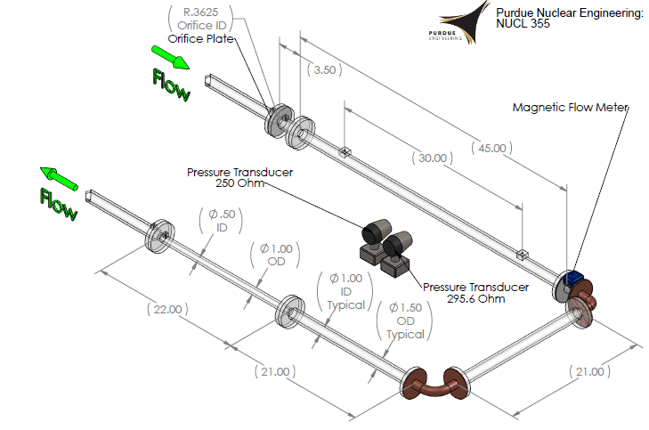

Figure .1 Experimental Setup (Drawn by A. Hagen)

With all of these flow elements set up consecutively, it is easy to take for granted a way to measure the pressure drops across the elements as well as other needed values within the experiments. A magnetic flow meter has been placed between the long pipe and sharp corner, which will take an accurate reading of the straight-line flowrate within the system. Two pressure transducers are used (in conjunctions with digital multimeters) for different ranges of pressures. These can be selectively attached to taps built into the system. The typical taps within the system are separated at typical flange tap distance (1 inch on either side), with the taps in the long pipe separated by 30 inches. Tubing connects these to the pressure transducers, and provides a way to measure the pressure drop over the orifice plate, the long pipe, the sharp corner, the smooth corner, the expansion and the contraction. The equipment used is listed below with comments and serial numbers.

|  |  |  |  |  |
| --- | --- | --- | --- | --- |
| Component | Manufacturer | Model | Serial Number | Other Information |
| Flow Meter | Yamatake | MagneW 3000 Plus | R-9YH19-41-034A | N/A |
| Pump | Franklin Electric | Model # 1113007485 | N/A | N/A |
| Pressure Transducer 1 | Honeywell | STD-924 | N/A | 295.6 Ohms |
| Pressure Transducer 2 | Honeywell | STD-924 | N/A | 250.2 Ohms |
| DC Power Supply | Tenma | 72-6610 | N/A | N/A |
| DMM | Fluke | 16 | N/A | N/A |
| DMM | Fluke | 115 | N/A | True RMS |

Table .1 Equipment Properties

# Data Acquisition

With an intimate understanding of the experimental setup as described previously, the data acquisition becomes an easy and straightforward process. Flange taps are present everywhere in the system except for across the long pipe, which has a tap separation of 30 inches. This means there is a tap for each flow element and a long distance of pipe. The data can then be taken independently and sequentially. For five different flow rates, the pressure drop was taken across each flow element using the Honeywell Pressure Transducers then attached to the Digital Multimeters. This means for each flow rate, a pressure drop was taken for the orifice plate, the long pipe, the sharp corner, the smooth corner, the contraction and then the expansion, in that order. This gives a good description of the effect each of the elements has upon the flow in the experiment.

# Analysis and Discussion of Data

For an exhaustive analysis of the data collected within this experiment, the data must be compared to other similar data. The only similar data available is the data available from other stations within this experiment, although some of the data may be compared to accepted values.

Table .1 Reynold's Number vs. Minor Loss Coefficient

The loss coefficients are the most derived data calculated within this experiment. The pressure losses across two different types of corners were measured. Using the flow rate measured across the entire system, as well as the geometric factors involved, the coefficient was able to be solved for, as shown in the sample calculations. These coefficients, when compared to the Reynold’s number, give a distribution as shown. It is obvious that the coefficient should be approximately constant across a range of Reynold’s numbers, with the sharp corner having more loss than the smooth corner. This is physically intuitive, as the water will exert more of its energy into a wall that approaches quicker, than in a larger radius which provides greater distance to “turn” around the corner. There is one point at lower Reynold’s Numbers for each elbow that doesn’t follow the trend, and is much higher than the other points. It is possible that this is a threshold type relationship, only holding true above Reynold’s numbers around 40000, or perhaps there is some other physical phenomena which causes this artificial rise in the loss coefficients. Regardless, the chart above gives detailed information about the relationship between Reynold’s number and the minor loss coefficients.

The case for the relationship between Major Loss and Reynold’s Number is much simpler. As shown in the chart below, there is an exponential increase in Major Loss as the Reynold’s Number increases. Again, this follows a physically intuitive trend, that as more energy is introduced into the liquid, more energy is lost to the same amount of friction in the wall. This follows the equation for Major loss and its dependence on Reynold’s Number and velocity:

Table .2 Reynold's Number vs. Major Loss

The analysis of the two simplest types of loss, in major and minor loss within elbows shows several relationships that are easy to define. The relationship between contraction loss, expansion loss, and major loss, are not quite as physically intuitive. Obviously, shown in the chart below, the minor loss in the contraction and expansion regions both increase exponentially with Reynold’s Number, but counter-intuitively, the values for expansion are much greater than the values for contraction. It is much easier to imagine the loss in water stagnating at the wall in a contraction case, but in expansion the loss is not apparent. In reality, eddies, or vortices, are created in an expansion case, and those create a much later pressure loss than the stagnation in a contraction case, and this loss also rises at a greater rate with Reynold’s Number. The chart below shows this relationship to very good experimental accuracy.

Table .3 Reynold's Number vs. Minor Loss in Contraction and Expansion Region

Now that each type of loss has been defined and analyzed, there must be a comparison between the loss occurring in pipe elements and the major loss throughout the entire pipe. The chart below shows the relationship between Reynold’s Number and the different types of loss that have been calculated. It is obvious through this chart that the expansion pressure drop dominates every other type of loss.

Table .4 Reynold's Number vs. Loss

Because it is difficult to visualize the types of loss as they relate to each other in the above chart (because expansion dominates the chart), the types of loss excluding expansion were charted on the same graph below. This shows conclusively that each of these types of loss increase with the Reynold’s Number in an exponential fashion, and that major loss is the most significant of these losses. It also shows that major loss and minor loss due to contraction are very similar in their values and their shape. This is helpful for intuitive thought about loss. It shows that an appropriate model for friction loss would be to slightly contract the pipe. This is a concept that seems to reinforce the idea of a boundary layer.

Table .5 Reynold's Number vs. Loss (without Expansion)

The two charts on the following page show just how unreliable the mathematical values for minor losses can be. It is shown that within contraction losses, the calculated values are underestimated by the mathematical model, significantly. The next chart shows that the expansion losses are vastly overestimated by the mathematical model, to the point that no variation is displayable on the chart in the real losses. This huge difference in the two types of minor loss highlights a key lesson from this experiment, that the mathematical models often have instabilities and are unreliable, and that experimental data should be used to benchmark all results.

Figure .1 Contraction Real vs. Calculated

Figure .2 Expansion Real vs. Calculated Loss

# Unusual and Unexpected Findings

There were many unusual findings within this lab, mostly involved with the accuracy of the data. The data that most easily identified as inaccurate are the values calculated for the minor loss within corners. Munson gives an estimate for sharp corners’ KL at around 0.2, and for smooth corners’ KL at 0.3 . The values calculated within this experiment never exceed 0.05, typically differing from expected values from Munson by over an order of magnitude. With this much error within the corners, it is easy to imagine the level of error that was created within the expansion and contraction, and other flow elements. For instance, it is difficult to believe that the fluid was flowing at up to 24 m/s through the small diameter pipe. Although the calculated error within this analysis seems reasonable, upon physical inspection of the calculated values, error is undeniably present.

# Conclusions, Recommendations and Comments

The conclusions in this experiment may be categorized through each different flow element within the system experimented on. The losses can be compared between the orifice, the long pipe, the sharp corner, the smooth corner, the contraction and the expansion. Each of these carries specific implications to the system, as well as comparisons to the other losses.

The orifice plate is the first pipe element within the system for data to be taken upon. Although this element was not exhaustively analyzed, it still showed large amounts of loss, with values for loss coming from 2.935878 kPa all the way up to 60.968848 kPa, enormous values for loss within a flow element. This is intuitive because of the geometry and properties of orifices, and the vortices that are created in high speed flow through these elements.

The major loss in the pipe was exhaustively analyzed, and was roughly equal to the loss in the contraction of the tube. This helps provide a physical understanding for the concept of a boundary layer, which is a layer of flow that is affected by the friction of the walls. The loss through major loss was calculated to be from 0.610073 kPa up to 8.748363 kPa. As Reynold’s number (and velocity) increased, this value increased exponentially, showing the relationship between these two values.

The sharp and smooth corners are very similar, with the smooth corner providing more loss (which is another intuitive result). The values for the smooth corner ranged from 83.694 Pa up to 1018.774 Pa, compared to the relatively lower values of 89.672 Pa to 302.892 Pa for the sharp corner. These were also plotted against Reynold’s Number, showing an exponential rise.

An interesting result was obtained with the loss in the corners, as the loss coefficient calculated showed that it should be constant, with one outlier for low Reynold’s numbers in each different corner. This displays an instability in the chart of the loss versus the speed of the flow which is unexplained. Another notable point is that experimentally obtained values for the minor loss coefficient were up to one order of magnitude less than expected values.

Contraction is another source of minor loss, and as said before, exhibited similar values to major loss, with losses ranging from 377.274 Pa to 7477.502 Pa, with an exponentially increasing trend with respect to Reynold’s Number. Expansion, though is a much higher loss, giving losses from 27.797883 kPa to 156.671468 kPa in the experiment. When these values were compared against calculated values within the experiment, they were an order of magnitude off, at least. The contract value was an order of magnitude higher than expected, whereas the expansion was an order of magnitude (several, in fact) lower than expected. This shows that experimental results should be taken for the minor loss in expansions and contractions.

Recommendations for this lab are few. The lab was executed easily, with data being taken easily and analyzed simply through mathematical means. It would be helpful to somehow obtain results closer to the calculated values, but the lessons learned by having results orders of magnitude off may be important ones. Overall, this lab was enjoyable and provided a clear understanding of not only the sources of loss in a pipe system, but also the instabilities and shortcomings of current mathematical models for these losses.

# Works Cited

Fox, R. W., McDonald, A. T., & Prichard, P. J. (2004). *Introduction to Fluid Mechanics* (6th ed.). New York: Wiley.

Munson, Y. O. (2009). *Fundamentals of Fluid Mechanics.* Hoboken, NJ: Wiley and Sons, Inc.

Revankar, S. T. (2011). *Experiment 6: Friction in Pipe and Similarity Law.* West Lafayette, IN: Purdue University School of Nuclear Engineering.

# Appendices

## Original Data

|  |  |  |  |  |  |  |  |
| --- | --- | --- | --- | --- | --- | --- | --- |
| Flow # | Flow Rate (m^3/hr) | Orifice Voltage | Pipe Voltage | Sharp Corner Voltage | Smooth Corner Voltage | Contraction Voltage | Expansion Voltage |
| 1 | 10.885 | 5.813 | 3.624 | 3.045 | 1.608 | 3.804 | 2.311 |
| 2 | 9.271 | 4.525 | 2.652 | 2.480 | 1.548 | 3.106 | 1.954 |
| 3 | 6.000 | 2.562 | 1.699 | 1.582 | 1.327 | 1.760 | 1.344 |
| 4 | 2.445 | 1.405 | 0.997 | 1.168 | 1.205 | 1.316 | 1.034 |
| 5 | 4.585 | 1.932 | 1.483 | 1.339 | 1.180 | 1.641 | 1.241 |
| 6 | 7.230 | 3.253 | 1.936 | 1.862 | 1.363 | 2.362 | 1.582 |

Table .1 Flow Data (Original)

## Reduced Data

|  |  |  |  |  |  |
| --- | --- | --- | --- | --- | --- |
| Orifice Pressure (Pa) | Orifice Pressure Error (Pa) | Pipe Pressure (Pa) | Pipe Pressure Error (Pa) | Corner Pressure (Pa) | Corner Pressure Error (Pa) |
| 60968.848 | 13.165 | 1307.219 | 0.498 | 1018.774 | 0.498 |
| 44011.846 | 13.165 | 822.990 | 0.498 | 737.303 | 0.498 |
| 18168.216 | 13.165 | 348.226 | 0.498 | 289.940 | 0.498 |
| 2935.878 | 13.165 | -1.495 | 0.498 | 83.694 | 0.498 |
| 9874.031 | 13.165 | 240.620 | 0.498 | 168.882 | 0.498 |
| 27265.490 | 13.165 | 466.295 | 0.498 | 429.429 | 0.498 |
| Corner Pressure (Pa) | **Corner Pressure Error (Pa)** | **Contraction Pressure (Pa)** | **Contraction Pressure Error (Pa)** | **Expansion Pressure (Pa)** | **Expansion Pressure Error (Pa)** |
| 302.892 | 0.498 | 34519.611 | 13.165 | 653.111 | 0.498 |
| 273.002 | 0.498 | 25330.180 | 13.165 | 475.262 | 0.498 |
| 162.904 | 0.498 | 7609.586 | 13.165 | 171.373 | 0.498 |
| 102.126 | 0.498 | 1764.160 | 13.165 | 16.938 | 0.498 |
| 89.672 | 0.498 | 6042.907 | 13.165 | 120.061 | 0.498 |
| 180.839 | 0.498 | 15535.142 | 13.165 | 289.940 | 0.498 |

Table .2 Pressure Data Through Piping Elements

|  |  |  |  |  |
| --- | --- | --- | --- | --- |
| Flow # | Velocity (m/s) | Velocity Error (m/s) | Re | Re Error |
| 1 | 5.967 | 0.017 | 151263.663 | 44.234 |
| 2 | 5.082 | 0.017 | 128834.673 | 44.234 |
| 3 | 3.289 | 0.017 | 83379.144 | 44.234 |
| 4 | 1.340 | 0.017 | 33977.001 | 44.234 |
| 5 | 2.514 | 0.017 | 63715.562 | 44.234 |
| 6 | 3.963 | 0.017 | 100471.868 | 44.234 |
| Flow # | **Velocity through 1/2" pipe (m/s)** | **Velocity Error through 1/2" pipe (m/s)** | **Re through 1/2" pipe** | **Re Error through 1/2" pipe** |
| 1 | 23.869 | 0.017 | 302527.326 | 22.117 |
| 2 | 20.330 | 0.017 | 257669.347 | 22.117 |
| 3 | 13.157 | 0.017 | 166758.287 | 22.117 |
| 4 | 5.361 | 0.017 | 67954.002 | 22.117 |
| 5 | 10.054 | 0.017 | 127431.124 | 22.117 |
| 6 | 15.854 | 0.017 | 200943.736 | 22.117 |

Table .3 Flow Data

|  |  |  |  |  |  |  |
| --- | --- | --- | --- | --- | --- | --- |
| Flow # | Velocity (m/s) | Velocity Error (m/s) | Re | Re Error | Major Loss (Pa) | Major Loss Error (Pa) |
| 1 | 5.967 | 0.017 | 151263.663 | 44.234 | 8748.363 | 874.836 |
| 2 | 5.082 | 0.017 | 128834.673 | 44.234 | 6555.160 | 655.516 |
| 3 | 3.289 | 0.017 | 83379.144 | 44.234 | 3005.653 | 300.565 |
| 4 | 1.340 | 0.017 | 33977.001 | 44.234 | 610.073 | 61.007 |
| 5 | 2.514 | 0.017 | 63715.562 | 44.234 | 1860.082 | 186.008 |
| 6 | 3.963 | 0.017 | 100471.868 | 44.234 | 4196.137 | 419.614 |

Table .4 Major Loss Data

|  |  |  |  |  |  |  |
| --- | --- | --- | --- | --- | --- | --- |
| Flow # | Velocity (m/s) | Velocity Error (m/s) | Sharp Corner Minor Loss Coefficient | Sharp Corner Minor Loss Coefficient Error | Smooth Corner Minor Loss Coefficient | Smooth Corner Minor Loss Coefficient Error |
| 1 | 5.967 | 0.017 | 0.057 | 0.003 | 0.017 | 0.001 |
| 2 | 5.082 | 0.017 | 0.057 | 0.003 | 0.021 | 0.001 |
| 3 | 3.289 | 0.017 | 0.054 | 0.004 | 0.030 | 0.002 |
| 4 | 1.340 | 0.017 | 0.093 | 0.018 | 0.114 | 0.022 |
| 5 | 2.514 | 0.017 | 0.053 | 0.006 | 0.028 | 0.003 |
| 6 | 3.963 | 0.017 | 0.055 | 0.004 | 0.023 | 0.002 |

Table .5 Corner Losses Data

|  |  |  |  |  |
| --- | --- | --- | --- | --- |
| Flow # | Calculated Contraction Pressure Loss (Pa) | Calculated Contraction Pressure Loss Error (Pa) | Calculated Expansion Pressure Loss (Pa) | Calculated Expansion Pressure Loss Error (Pa) |
| 1 | 7477.502 | 8.725 | 156671.4679 | 8.725 |
| 2 | 5424.414 | 8.725 | 113654.388 | 8.725 |
| 3 | 2271.968 | 8.725 | 47603.13407 | 8.725 |
| 4 | 377.274 | 8.725 | 7904.797932 | 8.725 |
| 5 | 1326.717 | 8.725 | 27797.8832 | 8.725 |
| 6 | 3298.954 | 8.725 | 69120.94075 | 8.725 |

Table .6 Expansion and Contraction Loss Data

|  |  |  |  |  |
| --- | --- | --- | --- | --- |
| Re | Contraction Pressure (Pa) | Contraction Pressure Error (Pa) | Calculated Contraction Pressure Loss (Pa) | Calculated Contraction Pressure Loss Error (Pa) |
| 151263.663 | 34519.611 | 13.165 | 7477.502 | 8.725 |
| 128834.673 | 25330.180 | 13.165 | 5424.414 | 8.725 |
| 83379.144 | 7609.586 | 13.165 | 2271.968 | 8.725 |
| 33977.001 | 1764.160 | 13.165 | 377.274 | 8.725 |
| 63715.562 | 6042.907 | 13.165 | 1326.717 | 8.725 |
| 100471.868 | 15535.142 | 13.165 | 3298.954 | 8.725 |

Table .7 Contraction Real vs. Calculated

|  |  |  |  |  |
| --- | --- | --- | --- | --- |
| Re | Expansion Pressure (Pa) | Expansion Pressure Error (Pa) | Calculated Expansion Pressure Loss (Pa) | Calculated Expansion Pressure Loss Error (Pa) |
| 151263.663 | 653.111 | 0.498 | 156671.4679 | 8.725 |
| 128834.673 | 475.262 | 0.498 | 113654.388 | 8.725 |
| 83379.144 | 171.373 | 0.498 | 47603.13407 | 8.725 |
| 33977.001 | 16.938 | 0.498 | 7904.797932 | 8.725 |
| 63715.562 | 120.061 | 0.498 | 27797.8832 | 8.725 |
| 100471.868 | 289.940 | 0.498 | 69120.94075 | 8.725 |

Table .8 Expansion Real vs. Calculated

## Sample Calculations

### Voltage to Pressure Translation

#### Transducer 1

$$P\left(20mA*295.6Ω\right)=250 in Water=P\left(5.912 V\right)=62272.22 Pa$$

$$P\left(4mA*295.6Ω\right)=P\left(1.182 V\right)=0 Pa$$

$$P=\frac{62272.22 Pa}{4.730 V}\left(V\right)-(\frac{62272.22 Pa}{4.730 V}1.182 V)$$

#### Transducer 2

$$P\left(20mA*250Ω\right)=8 in Water=P\left(5 V\right)=1992.711 Pa$$

$$P\left(4mA*250Ω\right)=P\left(1 V\right)=0 Pa$$

$$P=498.178\frac{Pa}{V}\left(V\right)-(498.178 Pa)$$

### Voltage to Pressure Error

$$\frac{dP}{dV}=498.178$$

$$u_{P}=u_{V}*498.178$$

### Velocity

$$Q=vA$$

$$v=\frac{Q}{A}=\frac{Q}{π{\left(\frac{D}{2}\right)}^{2}}=\frac{0.00302\frac{m^{3}}{s}}{π{\left(\frac{0.00254 m}{2}\right)}^{2}}=189.941\frac{m}{s}$$

### Velocity Error

$$\frac{dv}{dQ}=\frac{1}{A}$$

$$u_{v}=\frac{u_{Q}}{A}=\frac{u_{Q}}{π{\left(\frac{0.00254 m}{2}\right)}^{2}}$$

### Reynold’s Number

$$Re=\frac{vD}{ν}=\frac{\left(189.941\frac{m}{s}\right)\left(0.00254 m\right)}{1.002*{10}^{-6}\frac{m^{2}}{s}}=481.487$$

### Reynold’s Number Error

$$u_{Re}=\frac{u_{v}D}{ν}=\frac{u_{v}\left(0.00254 m\right)}{1.002*{10}^{-6}\frac{m^{2}}{s}}=0.044$$

### Minor Loss Calculation

$$P_{loss,minor}=K_{L}\left(\frac{ρv^{2}}{2}\right)$$

$$K_{L}=\frac{2P_{loss,minor}}{ρv^{2}}=\frac{2\left(1018.774 Pa\right)}{\left(1000\frac{kg}{m^{3}}\right){\left(5.967\frac{m}{s}\right)}^{2}}=0.341$$

### Minor Loss Error

$$u_{K_{L}}=\sqrt{{\left(\frac{∂K_{L}}{∂P}\right)}^{2}u_{P}+{\left(\frac{∂K_{L}}{∂v}\right)}^{2}u_{v}}=\sqrt{{\left(\frac{2}{ρv^{2}}\right)}^{2}u_{P}+{\left(-\frac{4P}{ρv^{3}}\right)}^{2}u_{v}}$$

$$u_{K_{L}}=\sqrt{{\left(\frac{2}{\left(1000\frac{kg}{m^{3}}\right){\left(5.967\frac{m}{s}\right)}^{2}}\right)}^{2}(0.498 Pa)+{\left(-\frac{4\left(1018.774 Pa\right)}{\left(1000\frac{kg}{m^{3}}\right){\left(5.967\frac{m}{s}\right)}^{3}}\right)}^{2}(0.017\frac{m}{s})}=0.003$$

### Friction Loss in Pipe

$$P_{loss, major}=f\left(\frac{l}{d}\right)\left(\frac{ρv^{2}}{2}\right)$$

$$\frac{1}{\sqrt{f}}=-1.8\log\left({\left(\frac{\frac{ϵ}{D}}{3.7}\right)}^{1.1}+\frac{6.9}{Re}\right)$$

$$ϵ=0$$

$$f=\frac{1}{{\left(-1.8\log\left(\frac{6.9}{Re}\right)\right)}^{2}}=\frac{1}{{\left(-1.8\log\left(\frac{6.9}{151263.663}\right)\right)}^{2}}=0.016$$

$$P_{loss,major}=f\left(30\right)\left(\frac{(1000\frac{kg}{m^{3}}){(5.967\frac{m}{s})}^{2}}{2}\right)=8746.363 Pa$$

### Contraction Pressure Loss

$$P_{loss,minor}=K_{L}\left(\frac{ρv^{2}}{2}\right)$$

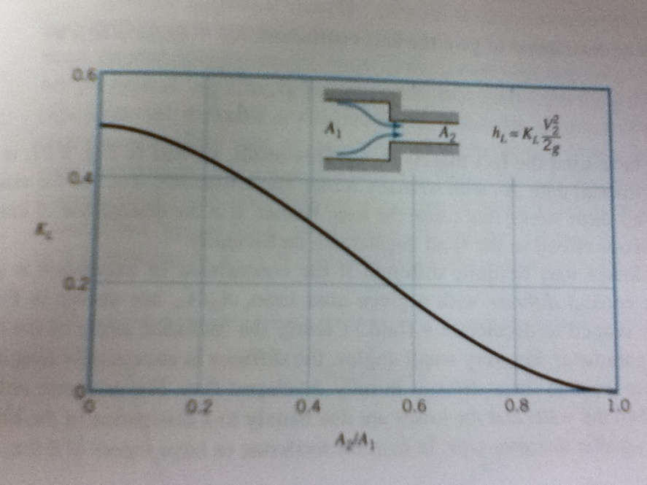

Figure .1 Minor Loss Coefficients (Contractions)

### Contraction Pressure Loss Error

$$u_{P}=u_{v}(\frac{ρ}{2})$$

### Expansion Pressure Loss

$$P_{loss,minor}=K_{L}\left(\frac{ρv^{2}}{2}\right)$$

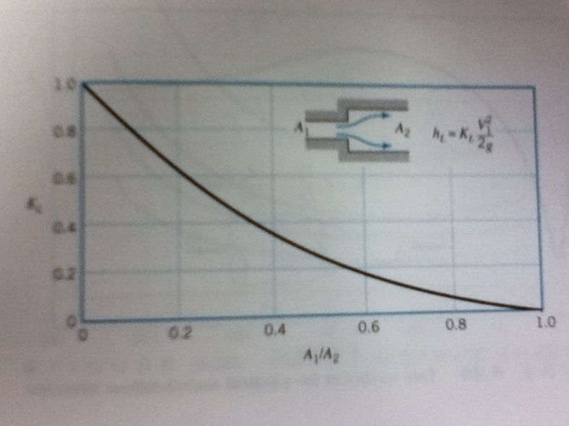

Figure . Minor Loss Coefficients for Expansion

### Expansion Pressure Loss Error

$$u_{P}=u_{v}(\frac{ρ}{2})$$

### Friction Loss Error

For the Colebrook formula solved analytically as done above, 10% accuracy is the best approximation one can make.

## Error Analysis

The error analysis has been done for this lab throughout the sample calculations. Please refer to them for a detailed analysis. If more accurate findings were desired, several flow rates and voltage values should have been taken at every step to better show the precision error based on flow rate and pressure measurement.